Order your DISTRICT 10 Tournament T-shirts ONLINE
Personalized with YOUR jersey number
$20
Order here:
www.tornadoalleysportswear.com

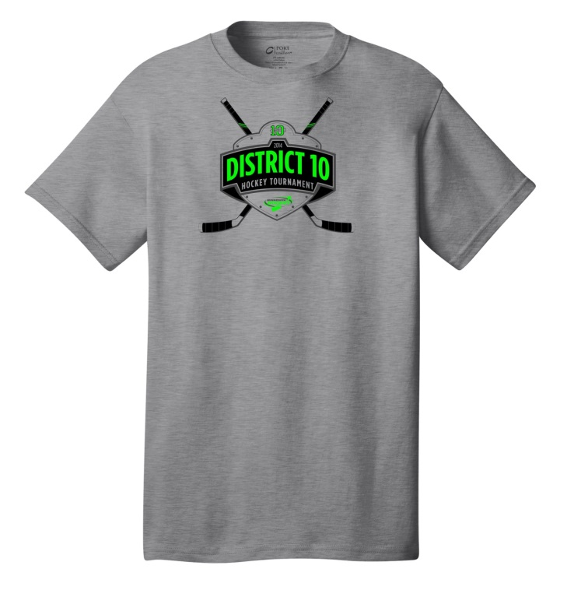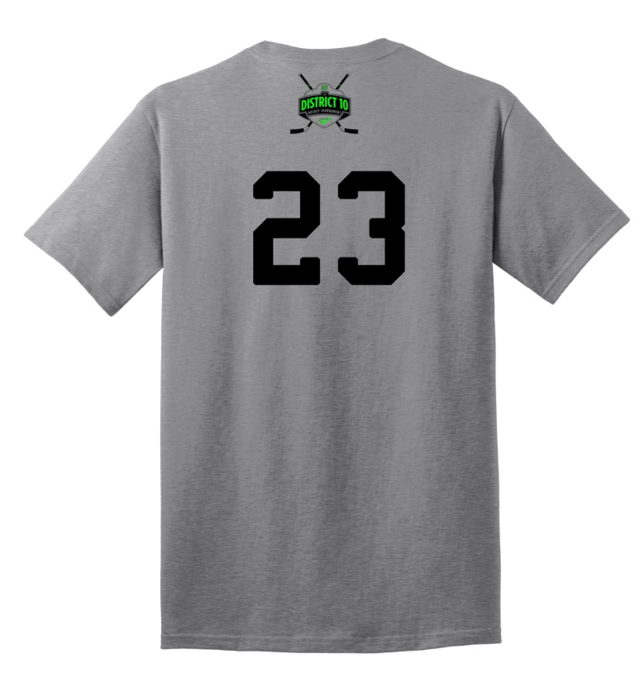Pickup at Anoka or Fogerty from Saturday 2/16 – Sunday 2/23 OR have it shipped

For questions or concerns contact:

(763) 951-3094
tasportswear@hotmail.com

